✴

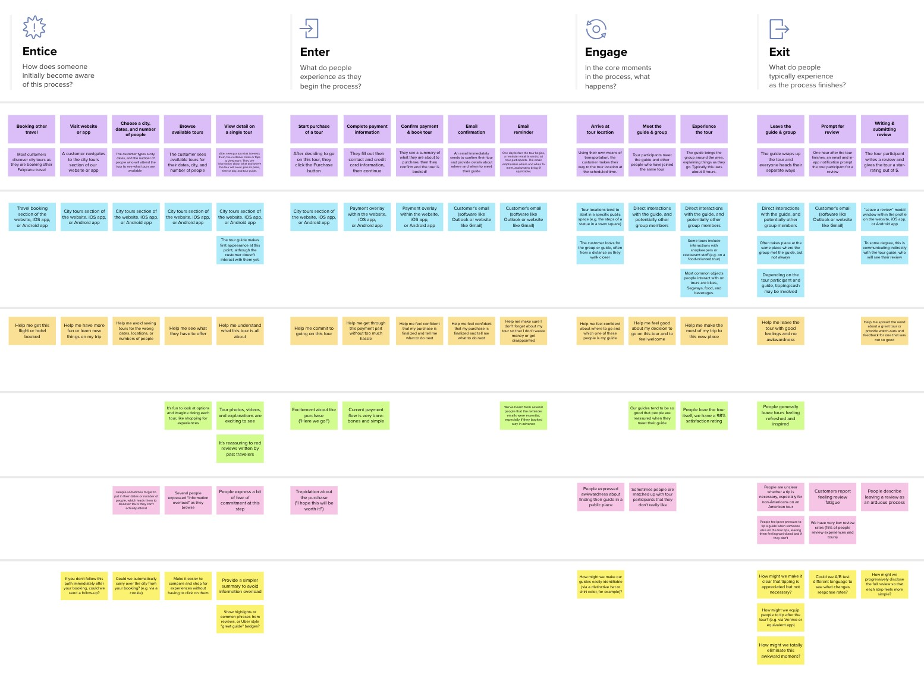

**Template**

Smart Farmer

**Smart Farmer Application Journey Map**

|  |  |  |  |  |  |  |  |  |  |  |  |  |
| --- | --- | --- | --- | --- | --- | --- | --- | --- | --- | --- | --- | --- |
| **SCENARIO**  **Browsing, booking, attending, and rating a local city tour** | **Entice**  How does someone initially become aware of this process? | | **Enter**  What do people experience as they begin the process? | | | | **Engage**  In the core moments in the process, what happens? | | **Exit**  What do people typically experience  as the process finishes? | | **Extend**  What happens after experience is over? | the |
| **Steps**  What does the person (or group) typically experience? | **Visit the website or app Check the Weather** | **Check the humidity** | **Login to the App**  The user should login to the app by using mail or phone number | **Check the Soil Moisture**  Using the app user can check the soil Moisture whether it is dry or not | **Viewthe Humidity of The soil**  App can intimate the Result | **Switch On the Motor**  If the field is Dry We can able to Switch on the Motor | **Alert Message** | **Switch on/off the motor** | **Ensure the yield of the crop** | **Submitting Feedback** | **Farming in the user profile**  In the customer profile they can see the data about the field. | **Personalized Work**  Farmer should not engage themselves fulltime in the field, they can feel relax by using this application |
|  | The user should The app first check navigate to our the Weather of  website or app particular location  today | **The app use hygrometer to measure the Humidity** | User can get alert when certain soil humidity level reached | Using app user can switch on/off the motor From anywhere | After the growth of the crop we can Ensure the yield of the crop | The User can writes areviewandgives ideas of the app |
| **Interactions** |  | |  | | | |  | | Customer's email  ( website like Gmail) | “Leave a feedback” modal window within the profileon the website, iOS app,or Androidapp |  | |
| What interactions do they have at each step along the way?  **People:** Who do they see or talk to? | Signup/SIgnin page for the users | | Weather Forecast shows the weather for routine days | | | | It show the Temperature and humidity of our field | | Completed experiences section of the profile on the website,iOSapp,or Androidapp | |
| **Places:** Where are they? |  | |  | | | |  | |  | |
| **Things:** What digital touchpoints or physical objects would they use? |  | |  | | | |  | |  | |
| **Goals & motivations**  At each step, what is a person’s primary goal or motivation? (“Help me...” or “Help me avoid...”) | Help me get the field Access from  temperature anywhere at anytime | Help me understand our Land Field and climate condition | Remotly we can access the motor switch | | | | Help me feel confident about where to go and spent time in other work | | Help me to see what could be doing next | |  | |
| **Positive moments**  What steps does a typical person find enjoyable, productive, fun, motivating, delightful, or exciting? | Increased quality of It Saves TIme and  production reduce labour cost | | Modern Technology Has Made Water Supply Simple | | | |  | | People love to remote access control, we have a 96% satisfaction rating | |  | |
| **Negative moments**  What steps does a typical person find frustrating, confusing, angering, costly, or time-consuming? | In some rural areas the network connectivity was poor | Some people don't know how to use the smart device | Rural People express a bit of fear to use technology | | | |  | |  | |  | |
| **Areas of opportunity**  How might we make each step better? What ideas do we have? What have others suggested? | provide a simpler information about smart farming | | By these technology most literate peoples are ready to do farming | | | |  | |  | |  | |



Created in partnership with



[**Share template feedback**](https://muralco.typeform.com/to/CiqaHVat?typeform-source=app.mural.co)

**Need some inspiration?**

|  |  |  |  |  |  |  |  |  |
| --- | --- | --- | --- | --- | --- | --- | --- | --- |
|  |  |  |  |  |  |  |  |  |

|  |  |  |  |  |  |  |  |  |
| --- | --- | --- | --- | --- | --- | --- | --- | --- |
|  |  |  |  |  |  |  |  |  |

|  |  |  |  |  |  |  |  |  |
| --- | --- | --- | --- | --- | --- | --- | --- | --- |
|  |  |  |  |  |  |  |  |  |

|  |  |  |  |  |  |  |  |  |
| --- | --- | --- | --- | --- | --- | --- | --- | --- |
|  |  |  |  |  |  |  |  |  |
|  |  |  |  | |  |  |  |  |

|  |  |  |  |  |  |  |  |  |
| --- | --- | --- | --- | --- | --- | --- | --- | --- |
|  |  |  |  |  |  |  |  |  |
|  |  |  |  | |  |  |  |  |

See a finished version of this template to kickstart your work.

|  |  |  |  |  |  |  |  |  |
| --- | --- | --- | --- | --- | --- | --- | --- | --- |
|  |  |  |  |  |  |  |  |  |

|  |  |  |  |  |  |  |  |  |
| --- | --- | --- | --- | --- | --- | --- | --- | --- |
|  |  |  |  |  |  |  |  |  |

[**Open example**](https://app.mural.co/template/f59f644b-b4b4-47b5-9ed6-3a8c71ceb612/896b31fe-5597-40ef-9b06-3811a1a45ace)